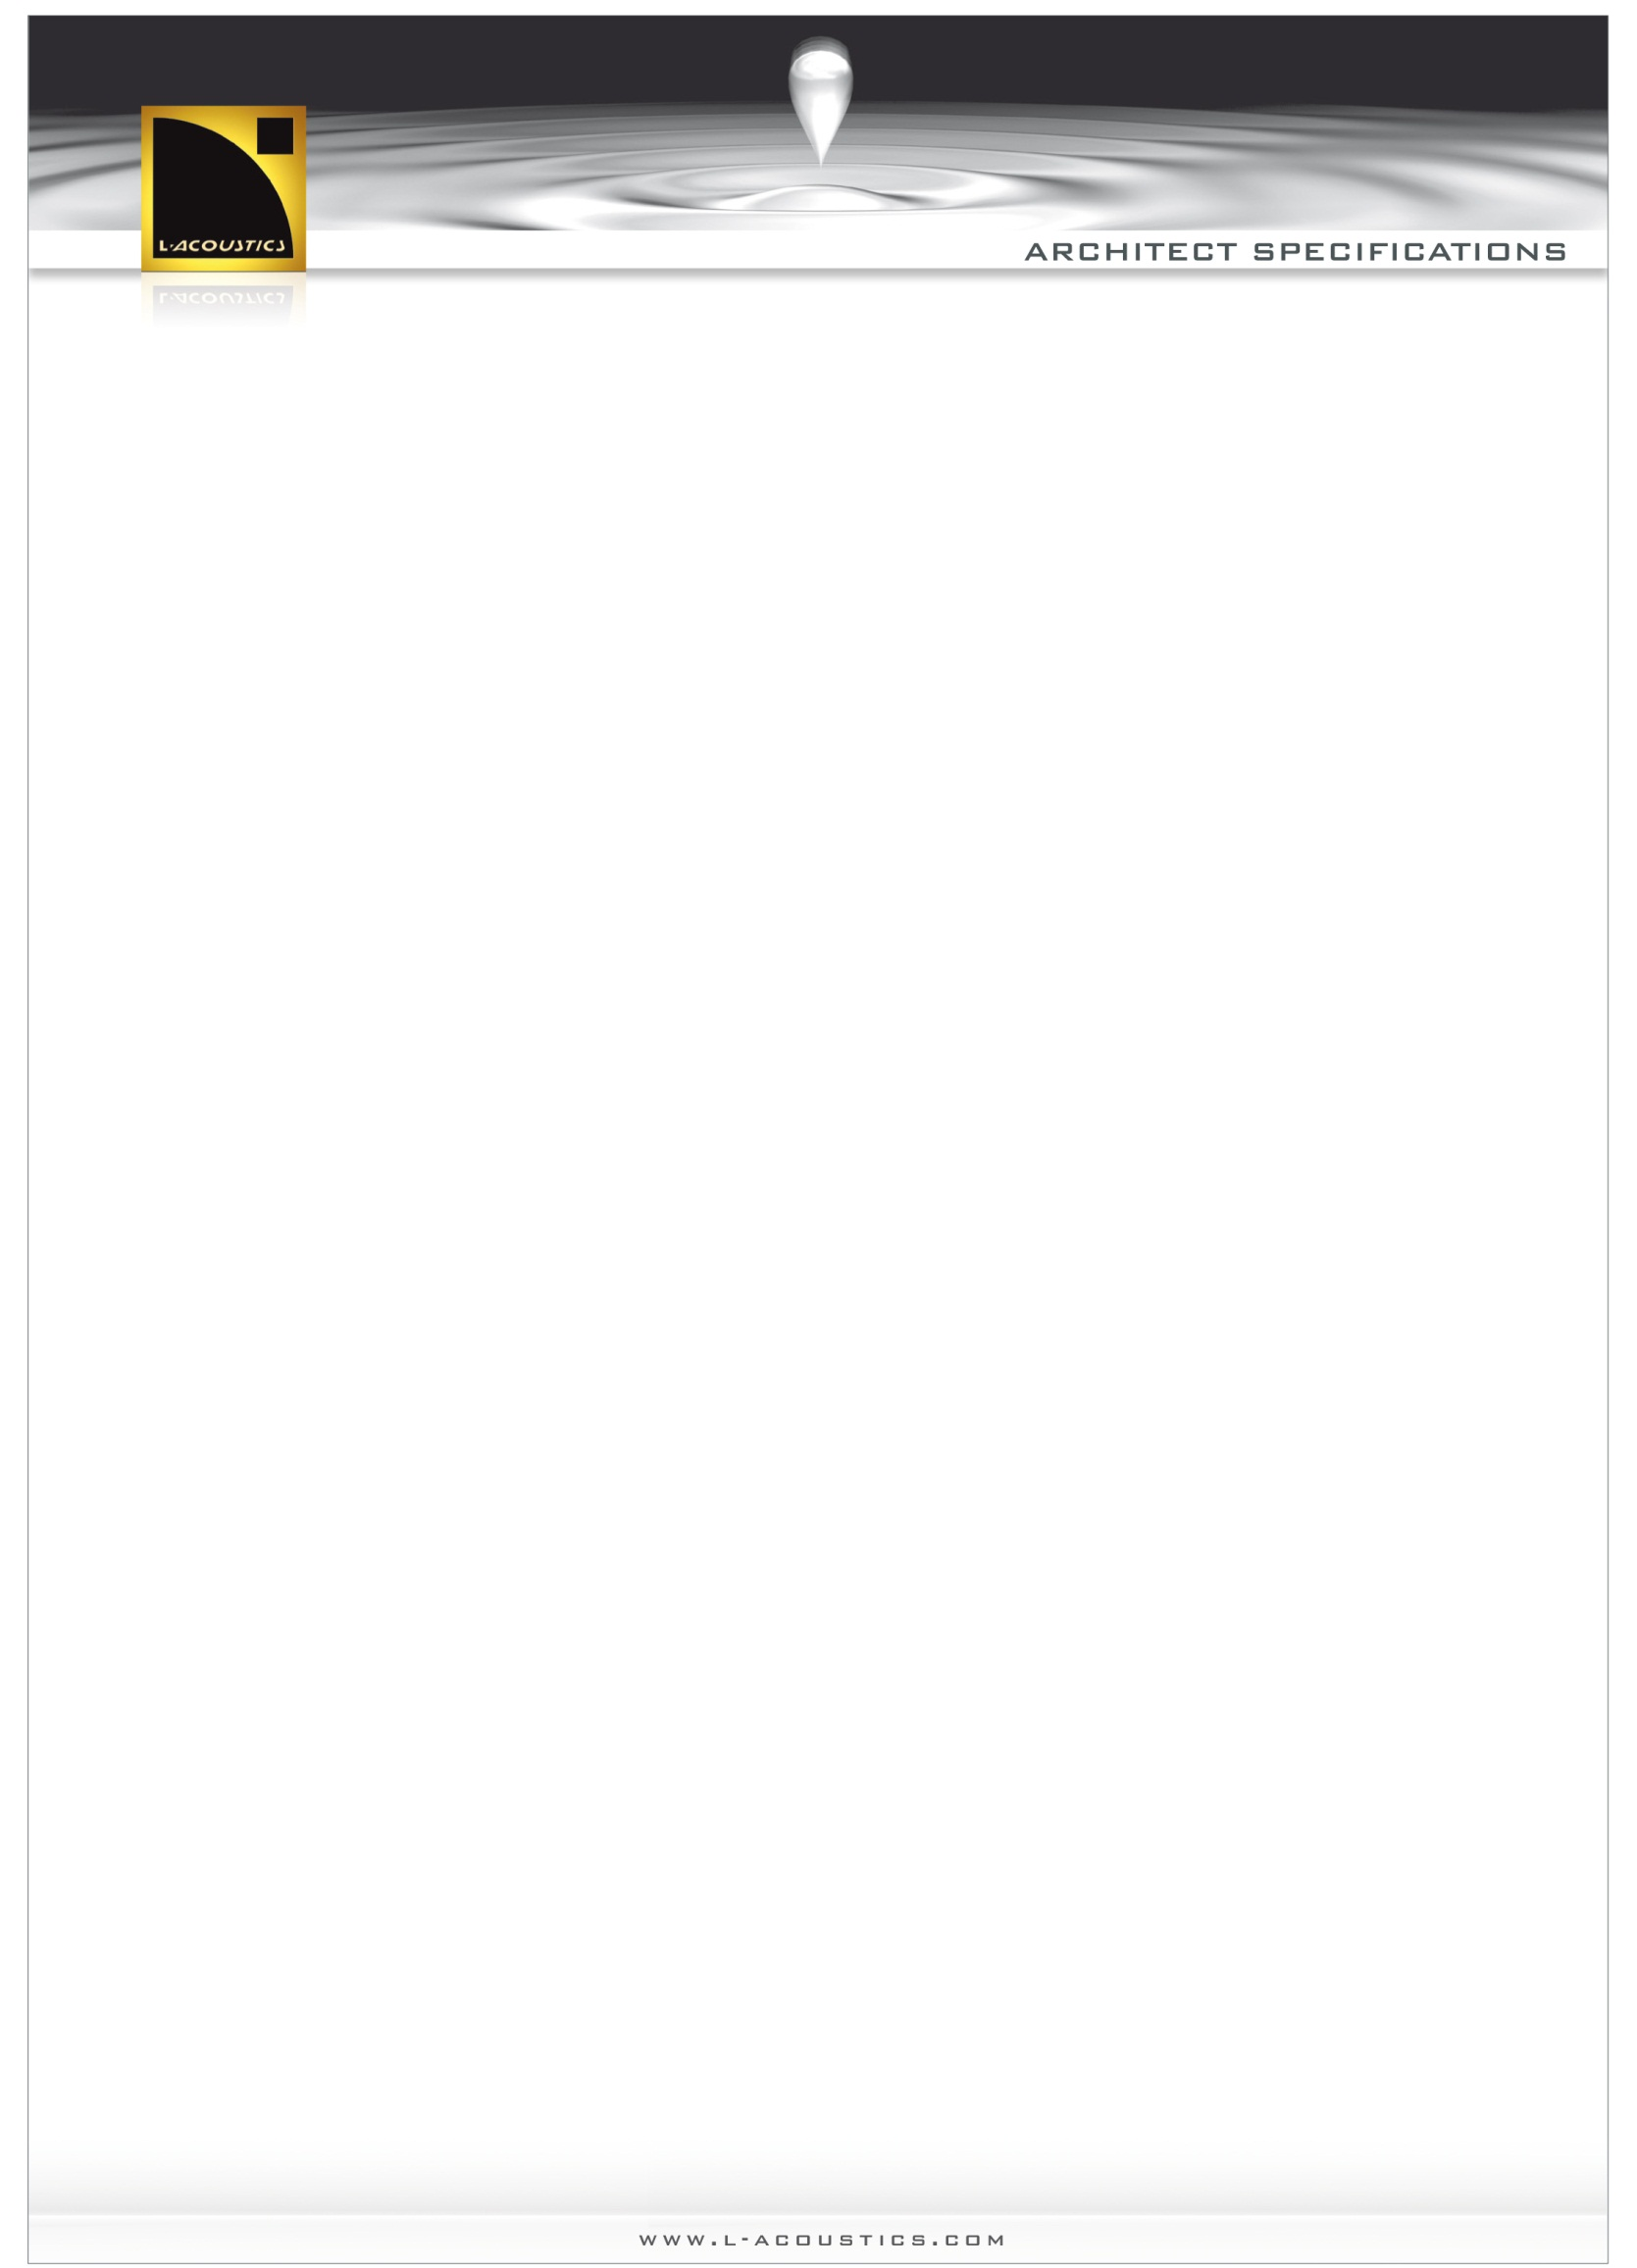

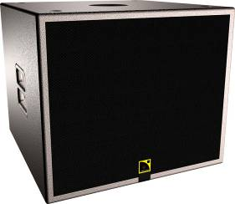

SB15P SYSTEM

- The system shall consist of a self-powered subwoofer enclosure. The enclosure shall feature a single 15-in weather-resistant loudspeaker component, front-loaded in a bass-reflex tuned enclosure.
The low frequency limit shall be 40 Hz. Maximum peak SPL, measured at 1m under half space conditions pink noise with crest factor 4, shall be 133 dB.

- Enclosure cabinet construction shall consist of Baltic birch plywood. Dimensions shall be 440 mm (17.3 in) height, 520 mm (20.5 in) width and 520 mm (20.5 in) depth. Enclosure weight shall be 36 kg (79.4 lbs). The front of the enclosure shall be protected by a sandblast-coated steel grill covered with acoustically-transparent fabric.
The loudspeaker shall have a 35 mm (1.38 in) diameter pole-mount socket located in the top panel allowing for full-range enclosure coupling. An adjustable U-bracket can be used for wall or ceiling flown applications. Connection to the loudspeaker shall be via two parallel XLR connectors. AC power connectors shall be PowerCon® type and 115V or 230V operation, selectable via rear panel slider switch.

- The system contains a speaker management DSP and a 2-channel power amplification module. The digital filter shall manage the system crossover network, driver time alignment, thermal protection and the linearization of the transducer.
The input shall be electronically balanced and the maximum input level shall be +12 dBu (gain potentiometer at 0 dB position). The power amplifier shall provide 1000 W continuous into 8 ohms. DSP sampling shall be 24 bits/ 48 kHz.

- The loudspeaker system shall be the L-ACOUSTICS® SB15P.
- The U-Bracket shall be the L-ACOUSTICS® ETR15P.

The response curves of the system are available upon request from applications@l-acoustics.com

